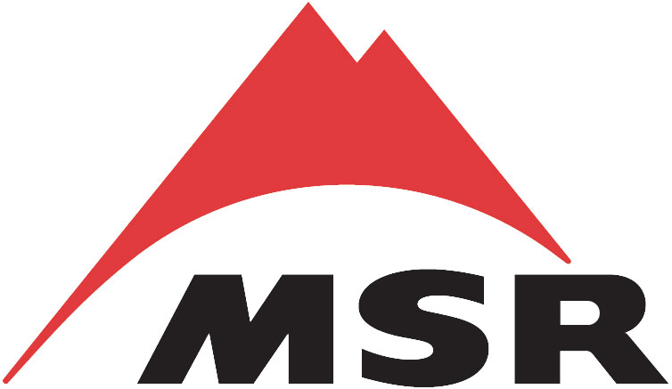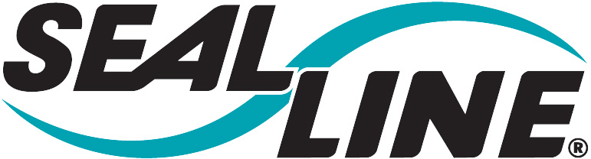

Friends of the Industry Pro Deal and Outfitter Sales Program

Forms
We’ve attached the necessary forms you’ll need for placing your order. You will need Microsoft Office Excel to view the forms. The order form and pricelist are both included on the accompanying Excel workbook. Use the tabs at the lower left hand corner of the workbook to switch between the two.

Ordering
You can place your order by email or fax, email is preferred. Please fill out the form completely and legibly (if faxing your order in). Cascade Designs is not responsible for items entered incorrectly due to illegible order forms. Organizations are allowed 4 orders per calendar year. If you are placing a large group order, please consolidate orders onto one form. This will expedite the order process and allow organizations to make more than one submission a year. If you are approved as an individual program member, this product is meant for you alone, not your friends or family. Please allow 4-6 weeks for your order. We accept checks, Visa, MasterCard and American Express cards. There is a $50 minimum order.

Shipping
Expedited shipping is not available on Friends of the Industry orders, no rush orders! When you receive your order, you will may not receive an itemized receipt. If it is important that you receive one, please contact us by email after you’ve received your order.

Returns
Please make sure that you’ve listed the correct part number and quantity on the form because there are no returns. Cascade Designs is not responsible for items entered incorrectly due to illegible order forms. If we find out that you are exchanging FOI purchased product through our retailers, we will terminate your account.

Discretion
The Friends of the Industry Program is intended to help outdoor professionals get the gear they need at a discounted price. This program is a privilege and should be treated as such. It is important that you maintain a harmonious relationship with our retailers. Please do not take up their time if you are not going to purchase the product from them. You should never mention the Friends program in front of any store’s customers. If people ask you about Cascade Designs equipment refer them to your local retailer.

Order Verification
If you need confirmation that we’ve received your order, email us at friends@cascadedesigns.com. Include the organization’s name (first line of the order form), the first name and the last name of the person ordering as well as any other information that may help us identify your order.

Checking out Product
If you need to check out our products, please refer to our website at www.cascadedesigns.com. All of our brands and products are available for viewing there.

Friends of the Industry
Cascade Designs
4225 2nd Ave S,
Seattle, WA. 98134
friends@cascadedesigns.com
Fax: 800-583-7583

